EXERCISE 07

1)[Subquery in Where clause] Identify all minions along with their hiring_charges involved in a mission with estimate greater than 2000.

select minion_id, hiring_charge from minion

where minIon_id in

(select minion_id from involved_in where mission_id in

(select mission_id from mission where estimate > 2000));

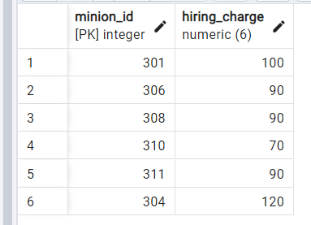

2)[Subquery in Where clause] Find all minions paid in Indian currency (INR).

SELECT * FROM minion

WHERE minion_id IN (

SELECT minion_id

FROM involved_in

WHERE mission_id IN (

SELECT mission_id

FROM payment

WHERE currency_id IN (

SELECT currency_id

FROM currency

WHERE name = 'INR')

)

);

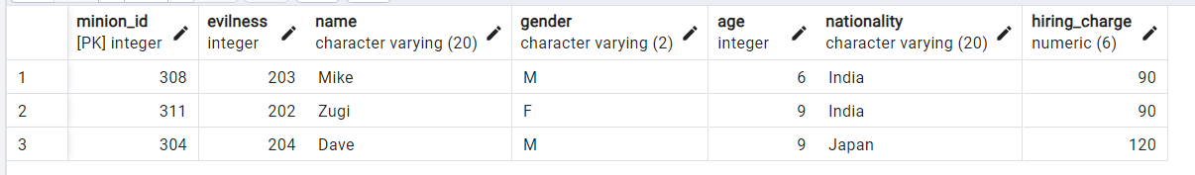

3)[Subquery in Having clause] Find the name and the hiring_charge of the minions with charges more than the average hiring_charge of the minions.

SELECT name, hiring_charge

FROM minion

GROUP BY minion_id

HAVING hiring_charge > (

SELECT AVG(hiring_charge)

FROM minion)

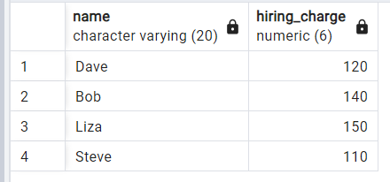

4)[Subquery in Having clause] Identify the trainers for mission 503.

**Hint**: level n trainer can teach level n-1. Vice versa is not true

select trainer from training

group by training_id

having level >= (

select pre_req

FROM mission

WHERE mission_id = 503);

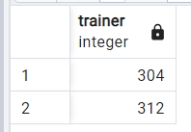

SELECT name FROM minion

WHERE minion_id IN (

select trainer from training

group by training_id

having level >= (

select pre_req

FROM mission

WHERE mission_id = 503)

);

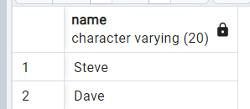

5)[Subquery in From clause] Find the Indian minions trained by Steve or Mike.

select distinct m.name

from minion m, (

select distinct minion_id

from takes_training

where training_id in (

select training_id

from training

where trainer in (312,308))

)

as indian_minions

where m.nationality='India' and

m.minion_id=indian_minions.minion_id;

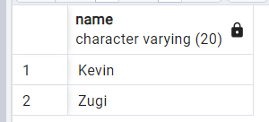

6)[Subquery in From clause] Which master from the cartoon genre have completed mission outside India.

select name,mtype from master,

(select distinct master_id

from involved_in

where mission_id in(

select distinct mission_id

from mission

where country not in('india'))) as cartoon_master

where mtype='cartoon' and master.master_id = cartoon_master.master_id;

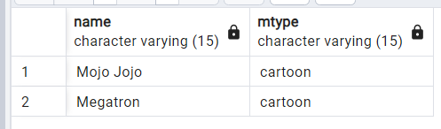

7)[Correlated Subquery] Find the missions with estimate higher than the average estimate of all missions.

select mission_id from mission as mi

where estimate >(

select avg(estimate) from mission m

where mi.mission_id = m.mission_id);

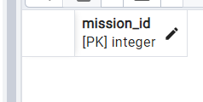

8)[Correlated Subquery] Compare the duration of all training and find all occurrences except the training with least duration.

SELECT * FROM training t1

WHERE t1.to_date - t1.from_date = (

SELECT MIN(t2.to_date - t2.from_date)

FROM training t2

WHERE t1.level = t2.level

);

